Boulcott expands with high-tech operating theatres
Justin Wong
August 4, 2025
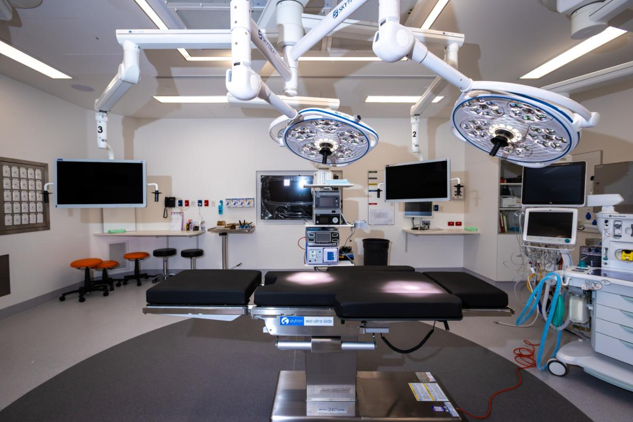Two state-of-the-art operating theatres are set to open at Lower Hutt’s privately-owned Boulcott Hospital on Monday, marking a major upgrade in surgical capacity and technology after three years of construction.
Fitted with advanced features like 4K imaging, three-position monitors, and integration with digital databases, the $25 million expansion is designed to future-proof the hospital’s surgical capabilities for the next decade. The new theatres will host their first surgeries the following week.
For Alison Fowler, theatre team leader at Boulcott, the upgrade is about more than just equipment—it’s about improving care. “We do a lot of keyhole surgery now, it’s done with telescopes and cameras,” she said. “It gives the surgeons great pictures, great views and they can perform at their best.”
The additional monitors also mean nurses can follow procedures from multiple angles without straining. “They’ll be able to see what’s happening on the table in different positions without sore necks,” Fowler said.
Hospital chief executive Graham Dyer said the new theatres would allow Boulcott to scale up after years of operating at full capacity with only three theatres.

“Demand for private care is exceeding supply, so it's an opportunity to expand and provide more capacity here in the Hutt.”
Dyer said they were doing sub-contract work for Health New Zealand, and believed that between 60–70% of elective surgery was now being done in the private sector—an increase from just over 50% before Covid.
The theatres were general purpose and could handle orthopaedic, plastic, ophthalmic and gynaecological surgeries, boosting the number of the hospital’s yearly surgeries from 3000 to 4700.
It was a very different scene in 1984, when the hospital’s co-founders took over and converted Argentina’s former embassy into a medical clinic. The transformation followed the expulsion of Argentine diplomats by the New Zealand Government in response to the Falklands War.
Chris Bossley, one of the founding doctors, said the new operating theatres would likely reduce patients’ hospital stays. “When I first started, someone with a hip replacement would be in hospital for 10 days,” he recalled. “Now they’re doing them in a couple of days in some places.”
Both Bossley and Dyer believed that expanding operating theatre capacity in the Hutt Valley could also help New Zealand retain its surgical workforce.
“You need some sort of attraction to keep surgeons in New Zealand,” said Bossley. “Good operating facilities are part of that.”
Currently, Dyer said, most surgeons worked across the public and private systems, with some Hutt Valley-based specialists walking next door to start their rounds at Hutt Hospital after they finished their work at Boulcott Hospital.
“It's that balance between being able to work in public work and private that actually will keep people here,” Dyer said.

